**Smart Expense Tracker**

**Phase 6: User Interface Development**

Three LWCs provide a modern UI for users:

1. **receiptUploader** → Upload receipts as attachments. Includes file preview before submission.
2. **expenseForm** → User-friendly form to enter and review expense details.
3. **expenseDashboard** → Graphical dashboard showing trends by month, vendor, and category.

Apex is integrated with these LWCs for data storage and retrieval, while wire adapters fetch real-time expense data.

**Lightning App Creation**

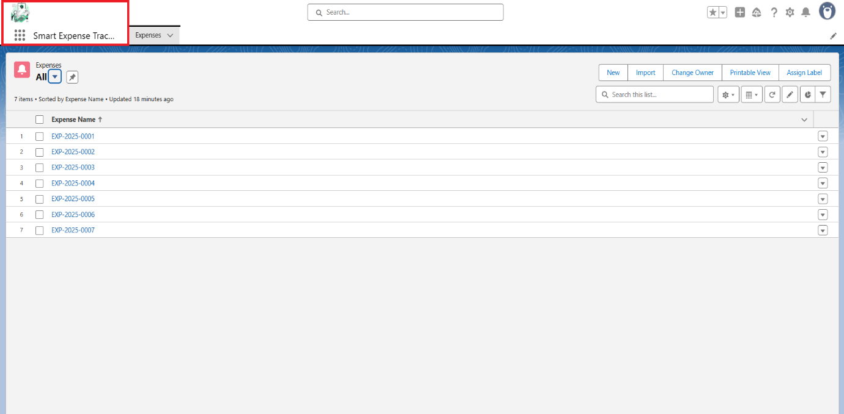

**LWC Page**

1. **receiptUploader.js**

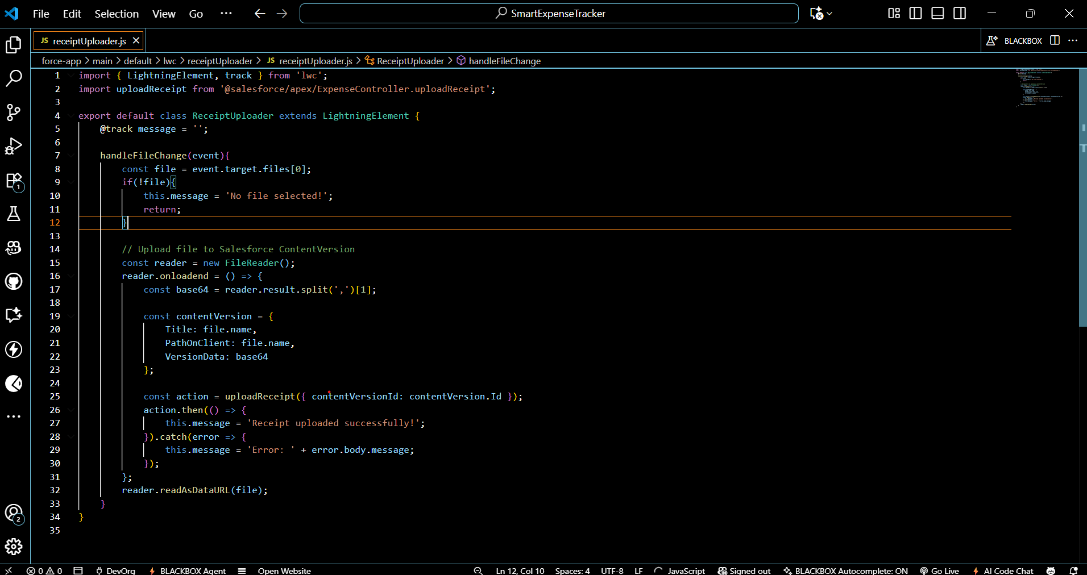

**2.receiptUploader.html**

**Lightning App Builder**

